**Farhaan**

. 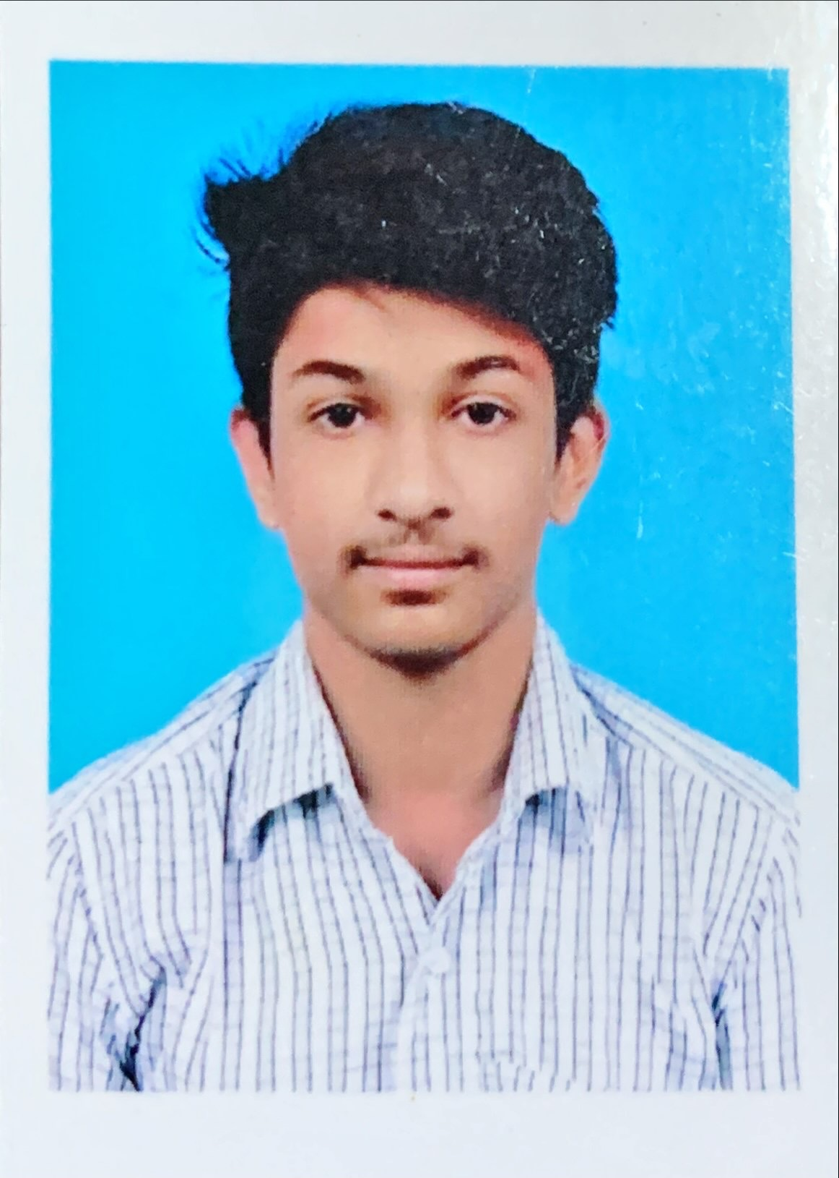



**Email Id:** [**farhaan.e0219031@sret.edu.in**](mailto:farhaan.e0219031@sret.edu.in)

**Contact number: 7994979560**

**Area of Interest: Web Development**

**Career Objective: -**

Desiring to implement real-time web development projects for more practical experience. Skilful and have enough knowledge to develop new applications.

**Education: -**

|  |  |  |  |  |
| --- | --- | --- | --- | --- |
| **Year of Passing** | **Board Examination or Degree** | **Institution Name** | **Board / University** | **Percentage / CGPA** |
| 2017 | Class X | SBOA Mat Hr Sec School | State Board | 93% |
| 2019 | Class XII | CEOA Mat Hr Sec School | State Board | 81% |
| 2023 | B.Tech. | Sri Ramachandra Engineering & Technology | Sri Ramachandra Institute of Higher Education & Research |  |

**List of Certified Courses Completed: -**

|  |  |  |
| --- | --- | --- |
| **Course Period** | **Course** | **Certification Provider** |
| Jun - July 2020 | Kotlin for Beginners | Udemy |
| Sep – Oct 2020 | The complete Javascript Course 2020 | Udemy |

**Projects Completed / Ongoing: -**

1. **Project Title: Android App Development**

**Status:** Completed

**Short Introduction:** A college search app is developed in order to view and search for college details and other info. Users can apply for colleges according to their preferences. Tools used are Android Studio, Kotlin and Firebase.

1. **Project Title: Data Analytics**

**Status:** Completed

**Short Introduction:** The project is based on Titanic Data Analytics. Various graphs were plotted using Tableau and were analysed. A website was developed about Titanic. The website was then hosted in AWS.

**Personal Information: -**

**Gender :** Male

**Date of Birth :** 23.06.2001

**Father’s Name :** AA Sadiq Ali

**Hobby :** Drawing, Music

**Address :** Fg4, Porkudam Apartments, Bypass road, Madurai 625010

**Nationality :** Indian